***Practical 6:***

**Program:**

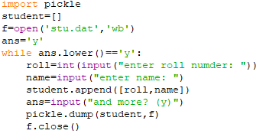

**OUTPUT:**

